**Abdalla Haitham Abdul Wahhab**

Computer Network Evening

Study

Stage 4

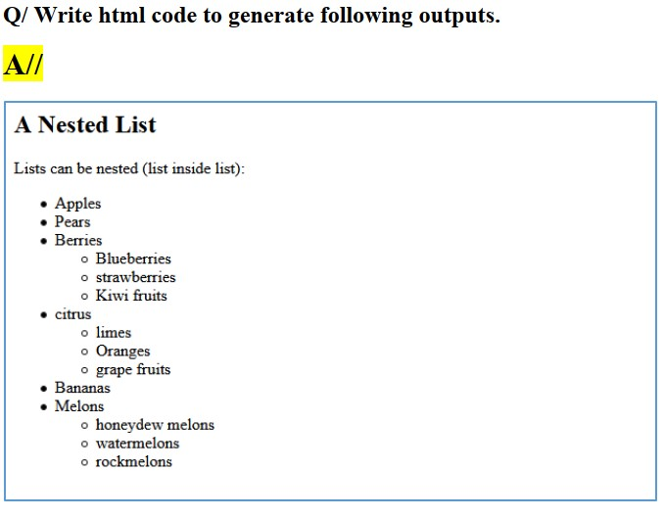

<html>

<head>

<title>Nested List Example</title>

</head>

<body>

<h2>All</h2>

<ul>

<li>A Nested List</li>

<li>Lists can be nested (list inside list):

<ul>

<li>Apples</li>

<ul>

<li>Pears</li>

<li>Berries</li>

<ul>

<li>Blueberries</li>

<li>Strawberries</li>

<li>Kiwi fruits</li>

</ul>

</ul>

<li>Citrus</li>

<ul>

<li>Limes</li>

<li>Oranges</li>

<li>Grapefruits</li>

</ul>

<li>Bananas</li>

<li>Melons</li>

<ul>

<li>Honeydew melons</li>

<ul>

<li>Watermelons</li>

<ul>

<li>Rockmelons</li>

</ul>

</ul>

</ul>

</ul>

</li>

</ul>

</body>

</html>

```

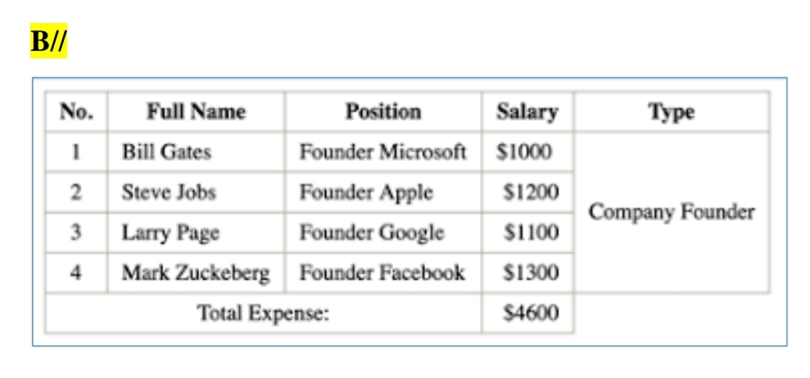

<html>

<head>

<title>Table Example</title>

</head>

<body>

<table border="1">

<tr>

<th>Full Name</th>

<th>Position</th>

<th>Salary</th>

</tr>

<tr>

<td>1</td>

<td>Bill Gates</td>

<td>Founder Microsoft</td>

<td>$1000</td>

</tr>

<tr>

<td>2</td>

<td>Steve Jobs</td>

<td>Founder Apple</td>

<td>$1200</td>

</tr>

<tr>

<td>3</td>

<td>Founder Google</td>

<td>Company Founder</td>

<td>Larry Page</td>

<td>$1100</td>

</tr>

<tr>

<td>4</td>

<td>Mark Zuckerberg</td>

<td>Founder Facebook</td>

<td></td>

<td>$1300</td>

</tr>

<tr>

<td colspan="2">Total Expense:</td>

<td>$4600</td>

</tr>

</table>

</body>

</html>